SGAGEARGREA

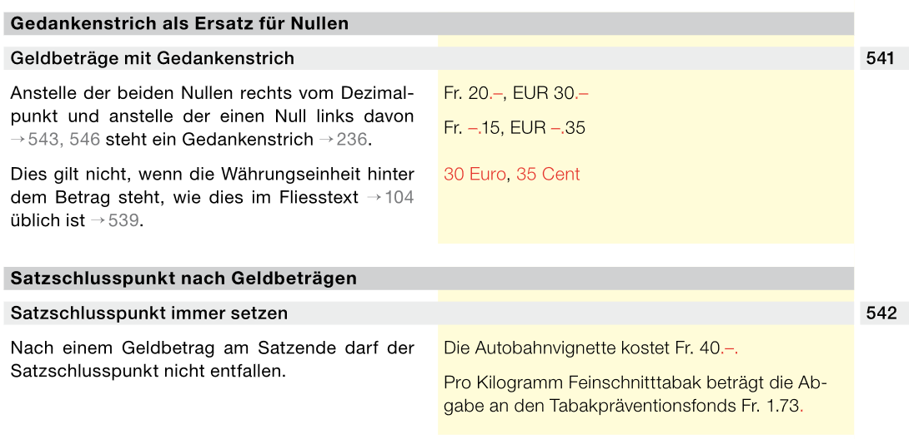
DFGNMFDNFDININL

