Manuscript painting tradition in Assam: A concise overview
Dr.Raj Kumar Mazinder

INTRODUCTION
In Assam, the art of painting has been developed around the culture of illustrating manuscript in line and colour. In other words painting as an art form is unique, valuable treasure of cultural heritage of Assam. Manuscript is simply hand written collection of both text and image for number of readers or viewers. Till late part of Nineteenth Century in Assam and before launching printing technology and printed book by Missionary people from western origin, manuscript book had great role as spreading, flourishing and also preserving wisdom and knowledge.
In the preface note on Assamese manuscripts S.K. Bhuyan wrote radically as, “From time immemorial the ancient kingdom of Kamrupa or Assam has been swept by a wave of Hindu civilization which has maintained its cultural homogeneity with the rest of India. Monarchs have resigned here whose exploits and achievements have been recorded in the Hindu epics and Puranas. Physically isolated, Assam was not outside the cultural hegemony of Aryyavarta. One vast means of conservation and transmitting Hindu civilization and culture was through puthis or manuscripts, elucidated by the verbal comments and explanations of the learned.”¹
It had no evidence of writing book on art in particular till twentieth century, though some important rhetorical word has been found in numerous old books of Assamese epic, poetry, ‘Charit puthi’/biography to signify various skill and aesthetics of art or eminent personality. In the context, the book entitled ‘Descriptive Catalogue of Assamese Manuscripts, by Pandit Hemchandra Goswami would be mentioned as earliest, which was published by Calcutta University in 1930. “According to Dr. Naren Kalita, the effort of Pandit Goswami fructified in the formation of a repository with a few illustrated transcripts in the library of Kamrup Anusandhana Samiti.”²
That period few number of people as Jyotiprasad Agarwalla, Sarbeswar Kataki, Rajmohan Nath was a few art loving connoisseurs in Assamese society. “Sarbeswar Kataki, a renowned scholar and archaeologist, wrote an article, in the Assamese monthly, ‘Awahana’, in its second year of publication (Vol. IV, p. 385-388) accompanied by 6 monochrome and 4 multi-coloured paintings from the manuscript titled ‘Anadipatan’ (Plate 4) & (Plate 5), in order to draw the attention of the people and the scholars to the rich heritage with a long tradition of about three hundred years of artistic activity.³
“The publication of the Chitra Bhagavata with paintings from the Bhagavata-purana, Book X (Adya portion) in 1949 was an epoch-making event. It was for the painstaking effort of Sahityarartna Harinarayan Dutta Baruah, a celebrated devotee of Srimanta Sankardeva’s neo-Vaishnavism, that the original illustrated treatise in the name of Adi Dasham’ of Bali Xatra in Nagaon got published.”⁴ And for the first time the people of Assam came to know about a rich tradition of artistic activities around the culture of painting. The Chitra Bhagavata is also significant for the scholarly introduction ever written in Assamese language on the growth and development of painting tradition in India. It was, in fact, a single man’s effort, a challenging task to publish an illustrated book with large number of monochrome and 117 multi-coloured paintings despite the limitation of print media and constraint of fund.
Afterwards great scholars as Maheswar Neog, Kapila Vatshyan, Rajata Nanda Dasgupta, Nilmani Phookan, Satyendra Nath Sarmah, Jugal Das, Birendranath Datta, Naren Kalita, Narayan Das, Rabin Deb Choudhury, Samiran Baruah, Kakoli Barkakoti immense input, detail and analytical study on the topic has enriched further in particular. Worth to mention that, the book entitled ‘Descriptive Catalogue of Assamese Manuscript’, based on the collection of Krishnakanta Handiqui Library of old manuscript books of Assam has been published by Gauhati University in 1999 which was edited by Dr. Satyendra Nath Sarmah.
In the present time, a rare scholar of Assamese language, literature, enduring devotee of neo-vaishnavite culture and former professor of Anundoram Dhekial Phukan College, Nagaon Dr. Naren Kalita, with his deeper study, scholastic thinking and analysis on old manuscript painting and art tradition, raise into academic vibes as well as in a higher perspective of glorious heritage of India. Associated with Srimanta Sankaradeva Kalakshetra in Guwahati since its inception this great personage has been not only collected lots of old books and but also working in various ways as research, conservation and also preservation and write several books in the context. As huge attainment of his life, two books are ‘Axomor Puthchitra’ in Assamese language (Publication Board, Assam, 1996) and another ‘An Alphabetical Index of Illustrated Manuscript of Assam’ (Published by Indira Gandhi National Centre for Arts, New Delhi, 2009). In various perspectives of erudite study and research on old manuscript books of Assam and related art discourses, these two books has certainly regarded as a milestone in course of time and textual resource.
In the next of title page of Dr. Kalita’s book ‘Axomor Puthichitra’ has been remembered and inevitably dedicate to those unknown, anonymous artists- “who was he, what’s his name, that Khanikar/creator of ‘Chitra-Bhagavata’ manuscript and similar unidentified artists- Khanikar clan and namely as Khankari fragrance has been known to all: some of their name as Dilbor- Dosai, Bishnuram- Purnakam, Sashadhar Ata, Durga Panchanan and Ghanashyam Khargaria Phukan, in remembrance to those artists”.⁵ He not only inscribes identity of those unknown, anonymous artists and their creation of manuscript, but also discussing comprehensively inner aesthetical juice and values along with study of text and feeling of those artists. To discuss about art in Assamese language, required art terminology or meaningful simile words are rather inadequate in numbers. In this aspect Dr. Kalita engages himself quite sincerely to look into authentic word from original Sanskrit text, English Glossary and also various oral languages; and use those words in both powerful command and perfection.
The contribution of Assam in various art practices since ancient period has been known from old Sanskrit text and copper plates of local kings. Story of political goodwill and cultural co-operation between Gupta Empire of Pataliputra and old royal king of Kamrupa had mentioned in various texts of history in India. ‘Dau Parvatia’ ruins of Tezpur and the impression or influence of Gupta period would be certainly narrating in detail that coloristic history of cultural connectivity.
In the circumstances, three main artist-clans have been mentioned in ‘Nagnajit’, an oldest text of art discourses. Among them, one is Prahalad and other two namely Biswakorma and Nagnajit respectively. According to old stories, Banasur was from that Prahalad clan. As looking into stories of Sonitpur and Banasur, Usha and Chitalekha, that Prahalad clan can be well connected with ancient Eastern India. Chitralekha, an expert of virtuosity in painting-dance-music, had done portrait-drawing in India for the first time. It must be an enduring tradition of various art practices for developing such a talent at the reign of Banasur.
In the text of Harshacharit several gift items had been mentioned as sending to Kaunoj’s Emperor Harshavardhana by Bhaskarvarman royal king of Kamrupa during seventh century. Some of items were manuscript books, art brushes, colour vessels, picture and blank art board. Evidence of decorated royal palaces during later kings of Bhaskarvarman has been mentioned in the excavated land endowment plates of that time.
During sixteenth and seventieth century Assam, Srimanta Sankaradeva launched a vigorous movement against numerous idol worship and awful belief/custom with his vernacular literature based on Vaisnavite text and preaching. He was alone responsible for the great bulk of literary output of his time. He translated many chapters of the Bhagavata-purana into old Assamese verses, wrote several Kavyas, composed six dramas and inaugurated new style of dramatic art, composed many devotional songs and the most celebrated work, the Kirtana, besides a kanda of the Ramayana and Sanskrit compendium, the Bhakti-Ratnakara, on bhakti. The culture of vernacular literature and Neo-Vaisnavite preaching was not only creating enthusiasm among common folk and learned people but also bring the entire people under one umbrella.
The art of painting got a new life in the hands of the extremely skilled artist of this era, Srimanta Sankardeva. “He drew the pat (pictures) of seven Baikunthas/ heavens for the performance of Chinha Yatra Bhaona (a folk theatrical performance) himself. Apart from these , the exquisitely painted ‘Brindavani Bastra’ (a kind of cloth) gifted by Srimanta Sankardeva to the king of Koch Bihar, Naranarayana, stands as a clear testimony to the excellence attained by this form during Sankardeva era.”⁶
The foundation and proliferation of the religious organisation called Xatra as a central institution for dissemination of religious morals among the people was a great boost for the promotion of literary activities and art. The 17th and 18th centuries were most active not only for the proliferation of different xatras in the entire warp and the weft of the Brahmaputra valley but also for the development of art and culture in the society. The emergence of a regional art form of painting can be attributed to the culture of manuscript copying in the xatra circles. Different Xatras patronized and supported the penmanship of craftsmen, called the Khanikaras under their wings. These craftsmen were involved various activities of Xatra as traditional carving as primarily associated with woodcrafts, viz, the carving of the lion-seat called Simhasana for enshrining the holy book, associating them with traditional theatre referred as Bhaona in mask-making, make-up men related imperative job. Their familiarities with colour and form of traditional theatre inspired them to create parallel pictorial forms in line and colour on the surface of the picture space left vacant by the scribe in the folios of manuscripts.
In the context, the Sachiitra Puthis (books having pictorial illustrations) which have been in various parts of Assam also proves the artistic talent of this land. Those pictorial illustrations were mainly found on Sanchi pat (i.e., the bark of Sanchi tree specially prepared for writing purpose) tulapat or tula-leaf and muga clothes. But due to frequent calamities occurring in Assam and inadequate techniques of preservation, a large number of manuscripts with valuable have become extinct. The Putichtras or painted manuscripts that have been rescued till now are- Chira Bhagavata, ( Dakham Skandha), Mahabharata, Ramayana, Kirtanghokha, Adi Dakham, Bhakti Ratnawali, Kumar Haran, Lava-Kusha Yudha, Darrang- Rajbonshawali, Hangkhasur Badh, Geet- Govinda, Kalki Purana, Ananda Lahari, Hasti Vidyanava, Dharma Puran, Ajamil Upakhyan, Ahom-Jyotish, Banamalidevar Charita, Matsya Charita and Shamudra Manthan. Among these, Namghosa and Ahom Jyotish are inscribed on muga clothes and the others are inscribed on Sanchi leaves. Although majority of the pictorial manuscripts are related to religion, yet few of them are secular too.
Thus illustrated manuscripts of Assam has been originated from the Xatras, the pictorial style inaugurated by the Khanikars of the Xatras may be designated as Xatria. As the within periphery of Xatra the Xatria style of manuscript painting evolved and develop in own formal ideal and motifs, but later period the Xatria style became more mature, enrich by exotic pictorial elements in connecting each other with Royal Ahom court manuscript painting style of 18th century which was influenced by the Mughal principles of pictorial art. Among the collected manuscripts with illustration till now, ‘Adi Dasham’ of Bali Xatra, Nagaon has been described by the scholars as earliest dated manuscripts of the end of 17th century possibly. Printed version of this manuscript is known as ‘Chitra-Bhagavata’.
STYLISTIC VARIETY OF PAINTED MANUSCRIPTS IN ASSAM
In the medieval times, basically in royal families and in the Xatras, the art of painting was widely practiced. In due course of time, the pictorial manuscripts in the two respective places acquired two different styles. Dr. Suniti Kumar Chattopadhyaya has divided the two styles into-
- Secular Royal style
- Religious Xatria Style
On the other hand, Dr. Rajatananda Dasgupta, who has done extensive research on Eastern India’s Chitraputhis or Puthichitras (books with pictorial illustrations), has divided them into seven styles. Various other research scholars have categorized the Puthichitras of Assam in their ways. After analyzing the results of the various researches, we can divide the medieval painted manuscripts in to following styles:
- Tai Ahom style, based on the religious books written in Tai-Ahom language
- Imperial or court style developed through the patronage of Ahom monarch
- Religious Xatriya style
- Darangi style developed on the basis of folk art
TAI- AHOM STYLE, BASED ON THE RELIGIOUS BOOKS WRITTEN IN TAI-AHOM LANGUAGE
The Ahoms were great patrons of book illustration like their Thai cousins. “The Ahoms brought manuscripts dealing both with religious and with secular matters.”⁵ All the Thai tribes between Upper Assam and Upper Burma were designated as the Naras by the people of Assam. Painting was popular among these tribes. They were linked by marriages as well as religious ceremony; paintings often were prized as dowry among these tribes and also sacred offering to monastery. Thus even after settling down in Assam, the Shan style of painting was continued due to constant contracts with the native land and kinfolk across the border of the Patkai. The style in Assam has been designated as the Tai-Ahom style.
Few books with pictorial illustrations belonging to this style group could be found. “The earliest extant examples of manuscript illustration in Assam are from the Phung Chin manuscript (Plate 1), dated 1473 A. D., belongs to Phake community and in the Tai-Ahom language/ script, which has been preserved in Namphake monastery near Dibrugarh town, Assam. It is a treatise on the Phake conception of heavens and hells as modified by animism as well Hinayana Buddhism.”⁷ There are a number of Tai manuscripts, mostly belonging to Buddhist Tai groups, in which are found various kinds of illustrations-from rough sketches and symbolic drawings to elaborate paintings. “While some of the paintings depict the other worlds and the plight of the souls in each of them according to the belief of the particular Burmese Buddhist sect with which these groups have religious links, some others illustrate Jataka stories. A good numbers of other Ahom manuscripts on indigenous oral chants has to be seen some monochrome illustrations of chicken-leg or chicken-bone in various positions from which predictions are to be made.”⁸
Another earliest evidence of painted manuscript, Suk-tanta kampong has several painted illustration of Buddha. These are written on folios of “tulapat” or locally made paper, folded and stitched together. “Painted manuscript ‘Gileswar Bailung Nemi Mang” of 17th Century and 18th Century Assam on Sanchi tree bark (Aquillaria Agallocha), is a unique discovery of Tai-Ahom treatise, digitisation recently by British Library, London. Mainly with line and less colour, lone Sachi tree bark leave has shown picture of a king like personality, smoking along with a deer, looking at the monkey in offering posture.”⁹
Significantly during 2006, with the publication of Catalogue of Ahom & Tai Manuscripts edited by Dr. Jogendra Nath Phukan and published by Department of Historical and Antiquarian Studies (DHAS), Assam have created land-mark in the field of Manuscript-studies as well as historical research in North-East India in general and Assam in particular. Since its establishment in 1928, DHAS has been collected a good number of manuscripts written in Tai language, original language of the Ahom of Buddhist origin, who were the ruling people for six centuries in the Brahmaputra valley before it came under the occupation of the British in 1826. Later on manuscripts written in other Tai languages like the Khamti, Aiton and Phake have been added to its collection.
IMPERIAL OR COURT STYLE DEVELOPED THROUGH THE PATRONAGE OF AHOM MONARACH
Historically, it is a fact that Assam in the early 18th century witnessed the exodus of several families of craftsmen from Mughal India which was on the verge of disintegration and decay. “The families, of course, immigrated to Assam at the behest of the Ahom king Swargadeo Rudra Simha (1695-1713 A. D.), showing his keen interest in search for skilled artisans in the Mughal territories of India. Thus the Mughal School of painting as well as its principles immigrated to Assam through these persons.”
The prominent painted manuscripts with pictorial illustrations of this style include- Hastividyarnava (Plate 2), Ananda Lahari, Hangkhasur Badh, Gita- Govinda, Dharma Puran, Kalki Puran, etc. “Hastividyarnava was composed in Saka 1636 (A. D. 1734) as known from the colophon, under the patronage of Ahom king Swargadeo Shiva Simha and his queen Rani Ambika. It appears perhaps that, originally compiled in Tai-Ahom language, may be without pictures of elephants, the text of the treatise Hastividyarnava was recomposed by author Sukumara Barkath(Kayastha), with materials drawn from Gajendra- cintamani. The paintings in the painted manuscripts were done by two eminent Muslim artists Dilbar and Doshai. They were undoubtedly expert in the line and used their brush with adroitness. There are 171 colourful pictures in Hastividyarnava. The colours used in the paintings are black ink, prepared from Silikha (terminalia citina) and bull’s urine, indigo, yellow ochre (Gerumati), vermillion (hengul), green and lamb black, taken from natural products in the main.”¹⁰ The background is portrayed with green and blue colours. The faces of the animals and men in the painting are set facing aside. All classes of elephants are illustrated with great precision, and their ailments and their appropriate remedies detailed in full.
During the time of the Ahoms there was a famous book belonging to the Shakta Dharma (the religious faction that worships Goddess Shakti) named Ananda Lahari. The paintings found in this book done by the most skilful artists of the time under the careful supervision of Borraja Phuleswari Konwari. As per the direction of king Swargadeo Shiva Simha and queen Phuleswari Konwari, the two books ‘Geet Govinda’ and ‘Hangsur Badh’ were translated by Kabiraj Chakraborty into the ancient Assamese language. The main themes of these two books were beautifully represented through paintings by the most eminent artists of the time under the direction of the royal authorities. The book ‘Dharma Purana’ was translated into Assamese language by the poet Kabichandra Dvij as per the orders of King Swargadeo Shiva Simha and queen Konwari Ambika Devi and, later on, the book was given a pictorial form by a ligira (a personal attendant). The epic ‘Kalki Puran’ was composed by poet Rusinath Kandali under the orders of king Rudra Simha and the paintings in it were ordered to be done by the most skilled artists of the time. Besides these, Bhagawatar Sastha Skandha’ (A. D.), Kirtan Gokha’, ‘Darrang Rajbangkhawali’, the eminent arist Durgaram’s pictorial version of the ‘Brahma Khanda’ of ‘Brahma Baivarta Purana’ (Plate 9) kept in the British Museum, ‘Kumar Haran’ that lies preserved in Budhbariya Xatra of Nazira are noteworthy.
RELIGIOUS XATRIYA STYLE
The pictures of Xatriya style and those carved out by the sculptor/ painter of Xatra on main worshipping book-keeping throne (Simhasan), cover of books, boxes for keeping books, on the walls of Xatra, etc. using hengul-haital (red and yellow pigments). We find that majority of the Chitraputhis or puthichitras (books with pictorial illustrations) belong to the Xatriya style.
Amidst these the ‘Adya Dakham Skanda Bhagawat’, authored by Srimanta Sankardeva found in Bali Xatra of Nagaon (Plate 6), is one of the oldest. It is recorded in the literature (Shastras) that the poems and paintings in this book were composed during the time period of 1539 A. D. to 16th Century. There are paintings and poems showing and describing the childhood and adolescent period of Lord Krishna’s life, Raslila (a festival of dance, music and games enjoyed by Lord Krishna with Gopinis/ female attendants), Vastraharan (Lord Krishna stealing the clothes of Gopinis), Gubardhan dharan (Lord Krishna carrying the Govardhan Parvat), Hangkhasur badh (killing of Hangkhasur), Naradar agaman (coming of Narad Muni), Kangkhabadh (killing of Kangkha) are most informative and fascinating ones. Some other valuable painted manuscripts of Xatriya style include- ‘Dasam’ illustrated by Rusi Bapu in 1765 A. D.; ‘Samundra Manthan’ found in Sivsagar; ‘Adya Dasam’ preserved in Dakshinapat Xatra; two volumes of ‘Bhagawat Puran’ prerseved in the British Museum of London; ‘Sachitra Ramayana’that lay preserved at Ahataguri Satra, Nagaon; ‘Langka kanda’ preserved by Upendranath Lekharu; ‘Sribhagawat Matsya Charitra’ and ‘Kumar Haran’ found in Mayaram Dinajay Xatra; ‘Bhakti Ratnavali’ found in Karatipar Xatra of Nagaon; ‘Bhakti Pradeep’ found in Samaguri Xatra of Nagaon, ‘Chitra Kirtan’ of Karanga, Jorhat; ‘Sachtra Parijat’ or ‘Parijat- harana’ (Plate 7) of Aibheti Na- Xatra, ‘Rangali Kirtan’ of Pub-thoria Madhav Ata Xatra, Anadi-patana, Samaguri Xatra, Majuli (Plate 8) etc.
DARANGI STYLE ON THE BASIS OF FOLK STYLE
Another school of manuscript painting saw its birth in the court of the Koch principality known as the Darang Raj of Mangoldoi in the district of Darang. Closely similar to the Xatria School of neo - Vaishnavism, from which originated, it soon developed its own characteristics which was later patronised by the Ahom Monarchs and Koch chiefs of the 17th and 18th centuries. The highly sophisticated Ahom courtly school of miniature painting also influenced that of Darrang. “The most important example of the later Darrang manuscript miniatures is the Darrang Rajvasvali (1791 A. D.), but it is proper to deal under Imperial style of Ahom monarch though its province is different.”¹¹ Among the works belonging to Darangi style, Tritiya Skandha Bhagavat, Dvijram’s Sahapari Upakhyan, Astam Skandha Bhagavat and Tirtha Kamudi are the most prominent. It is worth mentioning that this style evolved and developed in the Darrang region because of which it came to be known as the Darrangi style.
CONCLUSION
With the rise of the Neo-Vaisnavism under Shrimanta Sankardeva, from 16th century onwards, we get a host of concrete examples that can be called painting in its real sense that flourished until the last part of the 19th century. These polychrome paintings, popularly known as manuscript painting, done on sanchi pat or tulapat, were the illustrations of the stories of the Bhagavata, the Puranas, the Ramayana, the Mahabharata, etc., which contained written descriptions along with these paintings. At least one hundred manuscripts, each containing on an average forty such paintings, have been discovered so far. From these paintings, it is apparent that both their form and spirit are traditionally integrated with the basic aesthetic concept of the Indian painting tradition. For example in almost all these paintings the Hindu spirit of religious fervor is clearly visible.
During reign of Ahom rulers of Mongoloid/ South-east Asia origin in the Medieval Assam the Mughal influence became evident, yet it had been able like the Rajasthani and Pahari School to synthesize that influence to its own advantage, and thus had been able to maintain its distinct regional entity. That is why we find the similarity of manuscript paintings of Assam to be more striking with the Kangra School than with the Mughal School because of the thematic connotation and stylistic similarities. In the paintings of the manuscript of the first book of Brahmaavaivarta Purana which is now prescribed in the British Library, London, the Shankhachuda Vadha, the Hastividyarnava (of Auniati Satra) (Plate 3), Kumara Harana (of both Budhbari and Dichial Satras), we experience the highest manifestation of this assimilation.
On the other hand, in the paintings of the Chitra Bhagavata we experience something very original in its vigorous lines, contrast of colors and uniqueness of composition, which very well establishes its distinct identity. However, in all the above mentioned paintings we feel the same confident and effortless control of the painter over his job that reflected in the vigorous lines, arrangement of space and choice of colors. In his expert hands even the otherwise irrational and awkward arrangement of space become normal, perfect and pleasing. There is also a separate genre of paintings where, instead of trained, expert and confident hand we encounter the lines of confusion and simplicity of a child, where colors and composition also become arbitrary and irrational. But this irrationality often opens up a vista for a kind of innocent pleasure of fantasy which the rational thinking always fails.
It is worth to be mentioned that the paintings were traditionally done using vermillion red, yellow, blue, black, the colour produced from grey hilika (a kind of bitter fruit) and kharimati (white pigment). A kind of simplicity is reflected in the use of colours in Xatria art. On the other hand, one can find indigenous influence on the style of various objects like Simhasan, harai, etc. There is a picture of camel found on the Sanchi-puthi (book on bark leaves) ‘Samudra Manthan’ that has been kept in Sivasagar. Apart from the above mentioned chitraputhis or painted manuscript, there are numerous other painted manuscripts found to be preserved in the xatras located in the nook and corner of Assam. All these painted manuscripts done on Sanchi bark found widely in the nook and corners of Assam especially in Brahmaputra valley, beautifully illustrate the rich artistic tradition of Assam.
It may be mentioned here that all illuminated manuscripts do not contain paintings proper. Some of the folios of a manuscript are decorated with geometric and floral designs along with their borders and also at the centre. “Generally such designs are not frequently, sometimes each folio is treated with a specific design. Significantly, floral and geometric designs of similar nature are almost consistently found in the carvings and paintings on wood panels of and other articles associated with the neo- Vaishnavism order. A specific term- Lata-kata- has been traditionally used to designate such designs.”¹²
Taking into account what has been said earlier about apparent popular or folk style associated patuas and natas, coupled with the fact that paintings of some of the known illustrated manuscripts nhave obvious folk link, we can venture the conclude that at least some of different schools of manuscript painting has grown out of, or in mingling with, some indigenous folk styles; in some cases this had come about through a process of natural and independant evolution, and in some others as off-shoots of earlier refined styles, or as new development s through contact with more advanced styles developed elsewhere. “In paintings of the Hastividyaarnava it is to be seen to what extent the style of Hindu and Mughal (i.e. Indo-Persian with European influence) paintings were transformed by Mongoloid Boro or Ahom influence.”¹³
In early nineteenth century came the Burmese invasion in Assam with not only disastrous impact on socio-economic life, but also it almost ruined hundred years’ long art and cultural traditions of Assam. In 1826, after the Yandaboo Treaty, the British took over power from the Burmese. The Christian missionaries introduced printing technology at this time. British imperial reign had not only exploited that deplete situation of Assam as collecting some of treasured manuscripts to their own country, but also never encouraged nourishment of that manuscript painting tradition of Assam. In this juncture government, non-governmental agency, corporate bodies and above all viewers/ public has to be really responsive to take special care, attention and nourishment, also proper initiative towards those painted manuscripts tradition in this troubled torn part of our country.
References & Bibliography:
- Goswami, H, Descriptive Catalogue of Assamese Manuscripts, Historical and Antiquarian Studies, Assam, 2nd Edition, 2009, pp. xv-xxx
- Kalita, N, An Alphabetical of Illustrated Manuscripts of Assam, Indira Gandhi National Centre for Arts, New Delhi, p. 2
- Phookan, N, ‘Rup Borna Bak’, Students’ Stores, Guwahati, 1998, p.p 30-31
- Dutta Baruah, H. N, ed., ‘Chitra Bhagavata’, Nalbari, 1949
- Kalita, N, ‘Axomor Puthchitra’, Publication Board, Assam, 1996
- Bhuyan, S. K., The Administrative System of the Ahoms; p. 94
- Hamilton, F, “A Account of Assam”, pp. 78-79
- Datta, B, Folk Paintings of Assam, tezpur University, Tezpur, 1998, p. 8
- www. britishlibrary.typepad.co.uk/ 15.07.2013
- Chouddhury, P. C Ed., “Hastividyarnava” Publication board of Assam, Guwahati, 1976, p.p iv-xi
- Das Gupta, R, “Art of Mediaeval Assam”, Cosmo Publications, New Delhi, 1982, p. 120
- Datta, B, Ibid., p. 9
- Chatterjee, S. K., The Place of Assam in the History and Civilization of India, Gauhati University, Guwahati, 1970, p. 56 Datta, B, Ibid., p. 9

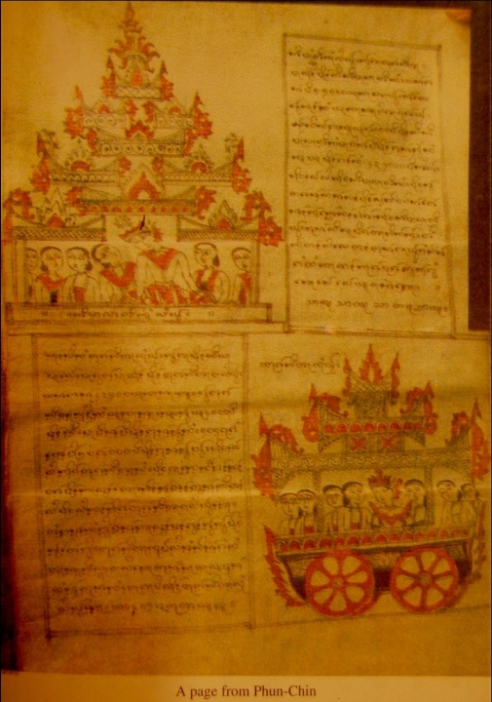
Plate 1, Phung Chin manuscript, 1473 A. D
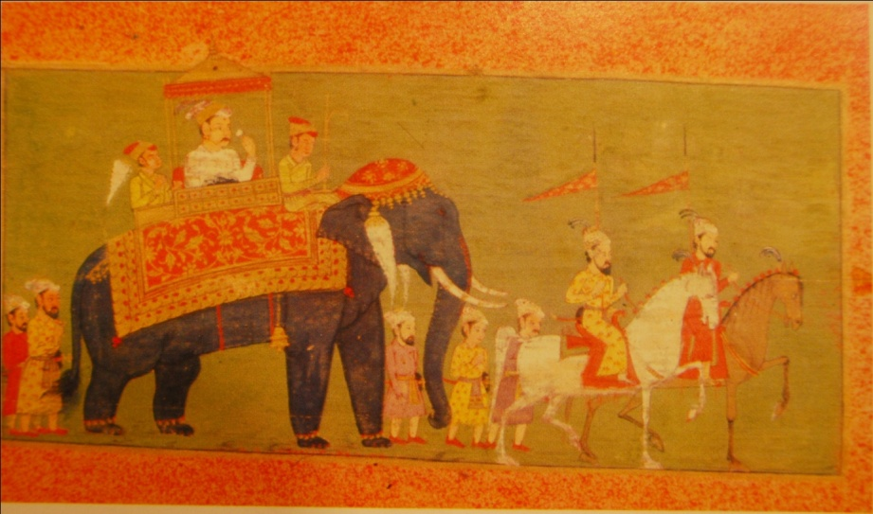
Plate 2, Hastividyarnava manuscript, Saka 1636 (A. D. 1734)
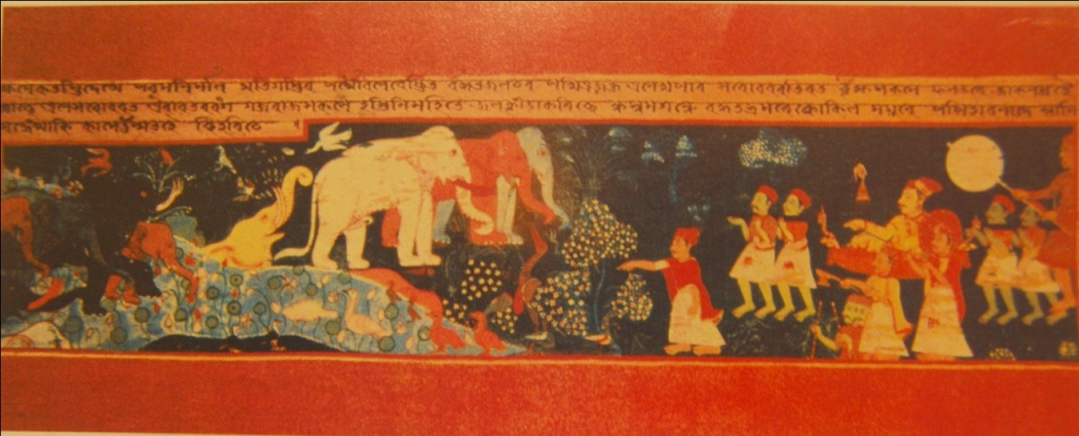
Plate 3, Hastividyarnava manuscript, Auniati Xatra, Majuli, late 18th century
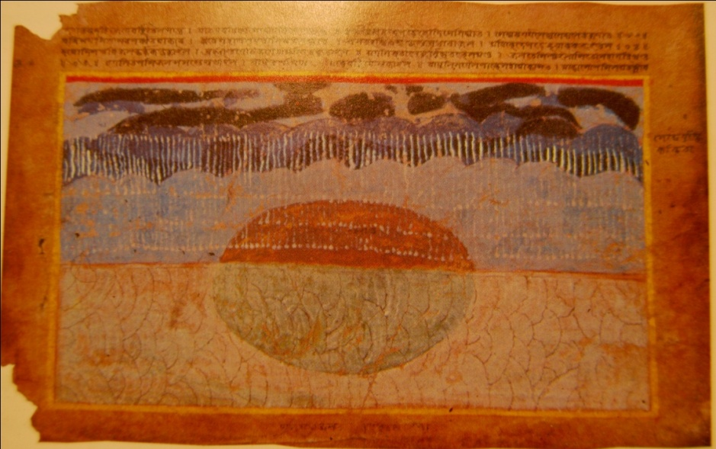
Plate 4, Anadi-patana manuscript, mid-18th century
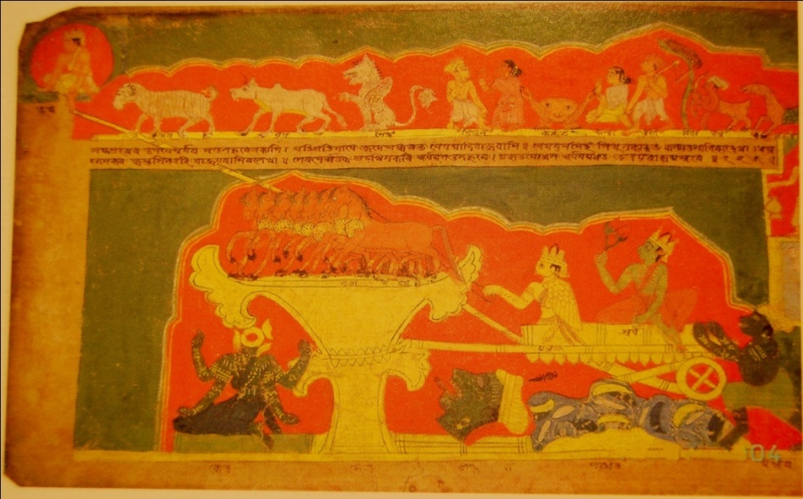
Plate 5, Anadi-patana, Kuji Xara, Nagaon, mid-18th century
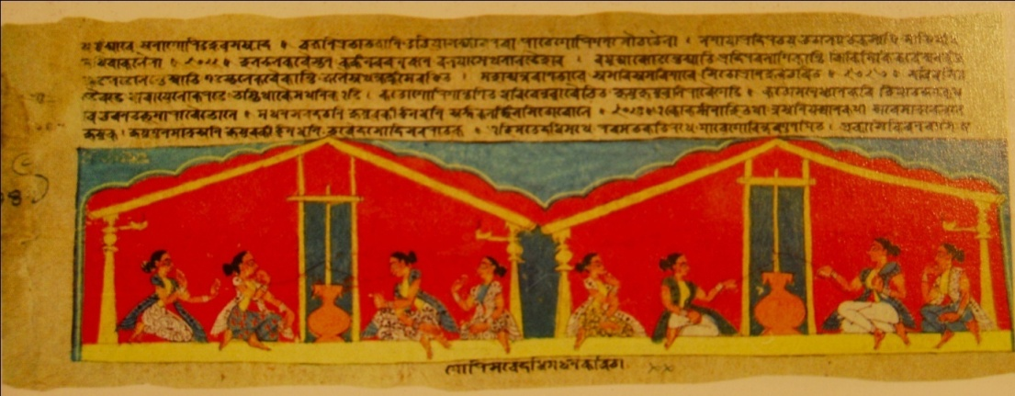
Plate 6, Bhagavata-purana (Adi-dasama) popularly known as Chitr Bhagavata,
Late 17th century
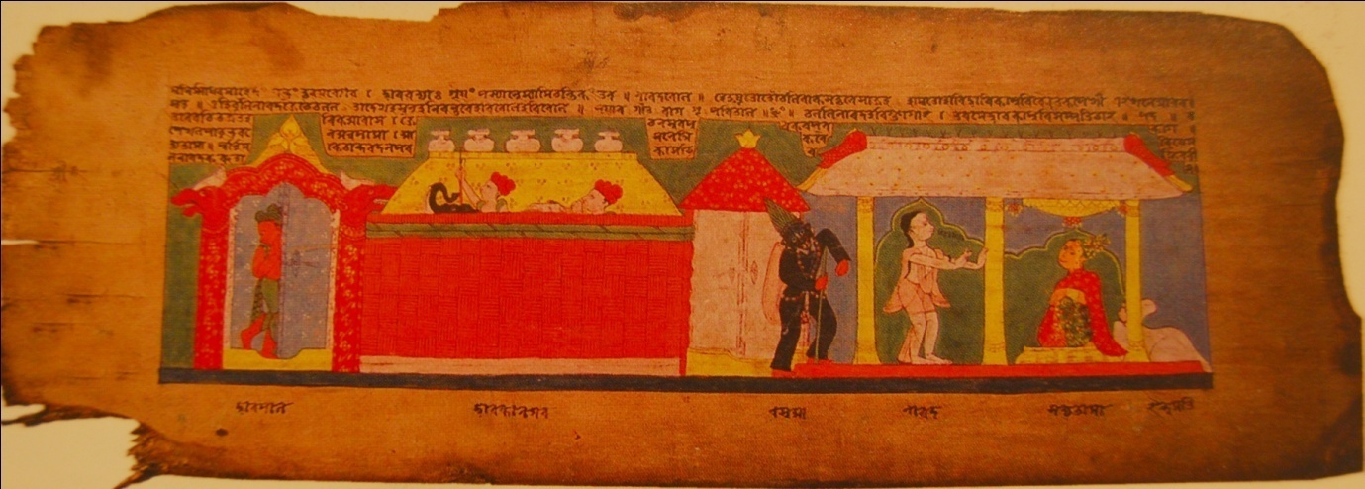
Plate 7, Parijata-harana manuscript, 1836 A. D.

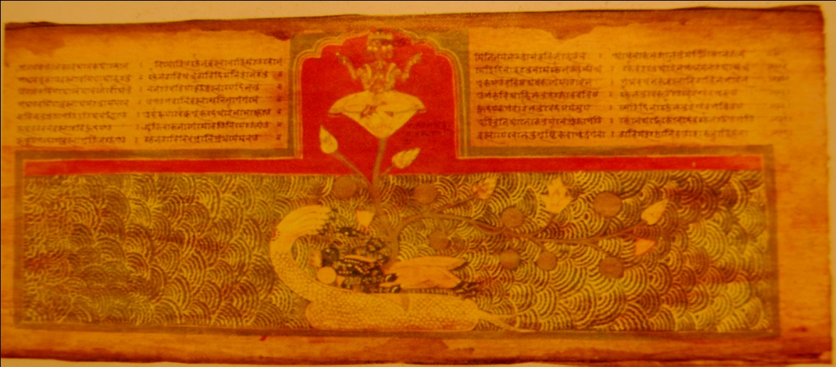
Plate 8, Anadi-patana, Samaguri Xatra, Majuli

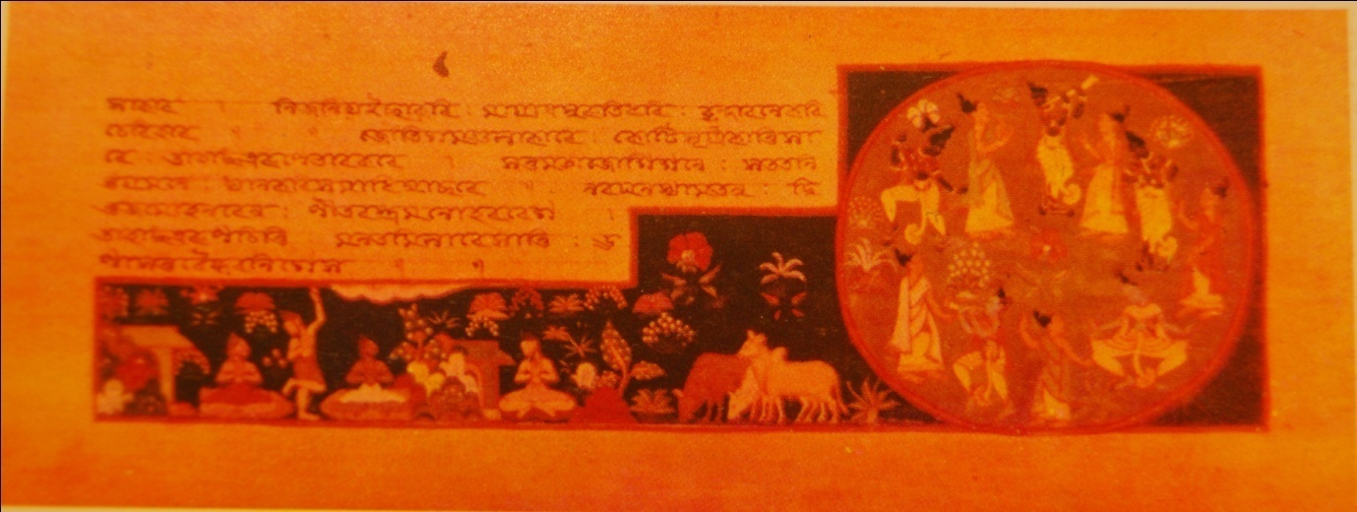
Plate 9. Brhma-Vivarta-purana (Brahmananda-khanda), Bitish Library, London, 1836 A. D.

